CMPEN/EE454: Computer Vision

Computer Project # 2:

Region Properties, Shape Recognition, and Image Filtering

Michael Mikulski, Zhenning Zhao, Kyle McCormick

Date: 09/28/2012

    - Objectives
The second CMPEN 454 project was intended to use methods used in project one to analyze and manipulate a set of images. This project specifically aims to get students to recognize model regions and perform image filtering techniques using MatLab.
    - Methods
2) After computing the image’s histogram in step #1 we began to investigate the graph in order to find a threshold that would yield us accurate results. In order to do this we used our judgment when analyzing the bright regions of the image. We came to the decision to choose 194. After using this value we received the desired result.
3)Next we had to find the connected components of the threshold image that was created from step #2. In order to do this we used a MATlab function called bwlabel. This function basically finds the connected components of a binary image. All the pixels for the connected components are given a level. It searches the connected component in a top-to-bottom scan order. All pixels in the first conected component is labeled -1 and those in the second as 2 and so on. This code was placed in our main.m file in which we assigned it to flabel such as: flabel = bwlabel(threshold, 4). We next used another MATlab function to displaye the labled image with colored components. We used the function label2rgb.We witnessed a green nose with a white face as a background. The eyes appeared to be orange and green as well.
5) For step 5 we needed to compute the bounding box, area, and the position. In order to grab the bounding box we needed to find the appropriate coordinates that the flabel had. For the bounding box we had a for loop that searched through the entire array and checked each element in the array to find the xmin, xmax, ymin, and ymax. Once we had these coordinates we were able to use them to create the bounding box of the image flabel. While the for loop was searching every element in the array we also had a counter variable called area that would correctly be populate the amount of elements in the array hence the area of flabel.
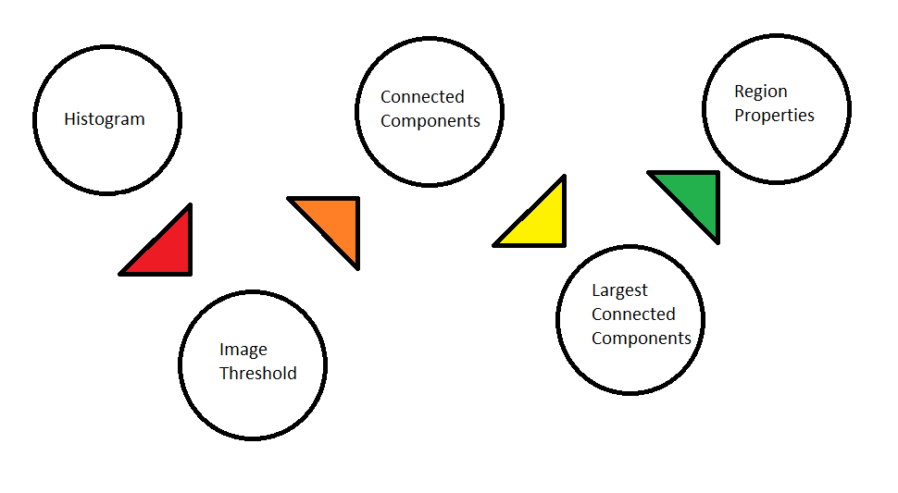

    - Results
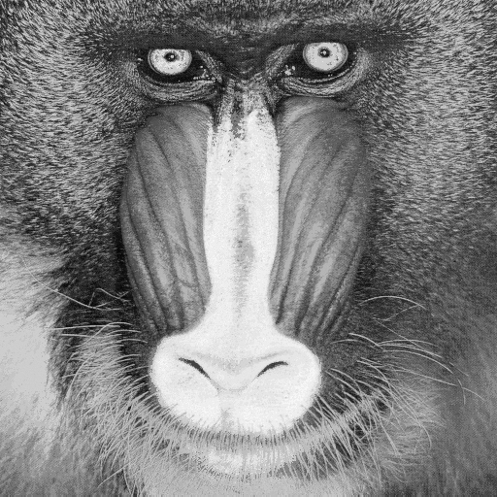
Figure 1. “Mandrill-red” Original image

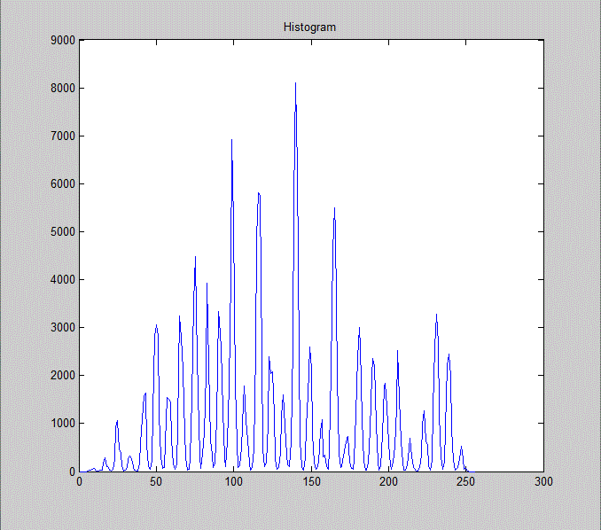
Figure 2. Histogram result after using the imagehistogram function from the original Mandrill-red image

Observations: ??????????????????????

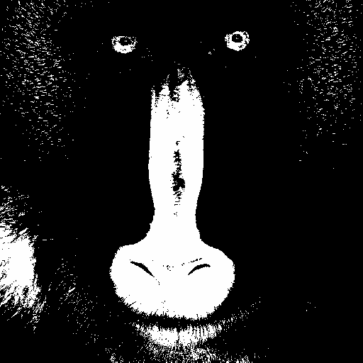
Figure 3. Threshold results after using the fthreshold function with a threshold value of 194

Observations: After using the threshold value calculated previously we can see the value is an accurate description of what the threshold image should look like. The brightest parts of the image such as the eyes, nose and a small part of the Mandrill’s fur should be distinctive when comparing it to the rest of the image. These bright parts of the image are what we wanted to highlight for the threshold image.

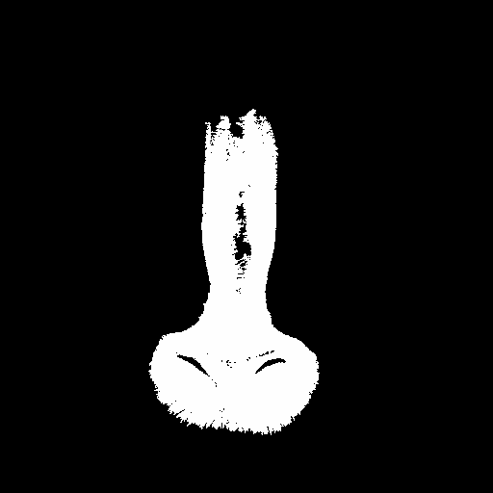
Figure 4. Largest Component result after using the largestcomponent function using the
threshold image

Observations: We received a correct largest component image as the nose is obviously the largest connected component in the threshold image. This connected component was preserved and the reaming part of the image was cropped from the image.

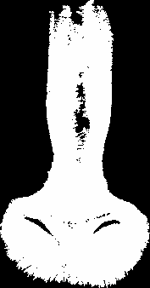
Figure 5. Bounded Box result after using the calculations function using
the largest component image

Observations: It’s clear that the bounding box is an accurate result when comparing it to the largest component image. The lines of the bounded box should skim the height, lowest, rightmost and leftmost parts of the largest component image. The rest of the image should simply be cropped to give a good representation of what the bounded box looks like

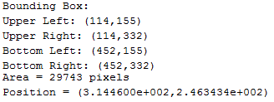
Figure 6. Final calculations for the bounding box, area, and position of the largest component image

    - Conclusions
Throughout the project we were consistently learning and researching how to use MATlab and upon reviewing our results we feel that we have successfully accomplished the main goal of the assignment – to be familiar with MatLab image manipulation. Our results in the beginning were incorrect since we were not accustomed to using the MATlab coding style. It took multiple tests and adjustments the correct output we were looking for. Upon completion of project 1 we believe that the assignment has properly introduced us to MATlab as we have been acquainted working with image manipulation functions. After this project we feel we are much more confident tackling more difficult assignments using similar techniques and practices with MATlab.

